**HAND GESTURE RECOGNITION**

**ABSTRACT:**

Over 500 million people worldwide suffer from physical, sensory, or intellectual disabilities. Their lives are often hampered by physical and social barriers that prevent them from fully participating in society and enjoying equal rights and opportunities. Many silent people use sign language. In sign language, gestures are used instead of sounds to convey meaning, and the shape of the hand, hands, arms, body orientation and movement, and facial expressions are combined to fluently express the speaker's thoughts. Signs are used to convey words and phrases to the audience. This project focuses on developing a system that recognizes hand gestures with reasonable accuracy, assuming input from the hand to the pattern recognition system. Recognize the pattern and display it in text format.

**HARDWARE REQUIREMENTS:**

Processor: I3

RAM: 8GB

Storage: 120GB

Webcam

**SOFTWARE REQUIREMENTS:**

OS: Windows 10 / 11

Python 3

**Introduction**

In sign language, gestures are used instead of sounds to convey meaning, and the shape of hands, hands, arms, body orientation and movements, and facial expressions are combined to express the speaker's thoughts fluently. Signs are used to convey words and phrases to an audience. More than 500 million people worldwide have physical, sensory or intellectual disabilities. Their lives are often hindered by physical and social barriers that prevent them from fully participating in society and enjoying equal rights and opportunities. Many people silently use sign language. This project focuses on developing a hand gesture recognition system with reasonable accuracy, assuming manual input into the pattern recognition system. Pattern recognition and display in text format. Human-computer interactions are currently performed using keyboards, mice, or various tactile devices. These tools do not provide sufficient flexibility for many uses, except that they differ from our natural way of interacting. B. Manipulating objects in a virtual environment. To improve the interaction between humans and machines an automatic hand gesture recognition system could

be used.

**Existing System**

Hand Gesture/Sign Recognition is an old problem and hence several researches has been ongoing to solve this effectively. Initially this was done using Hardware Interfaces by placing sensors on Palm and Finger, That data was further analysed and it system were able to detect limited Number of Hand Signs.

In terms of Machine Learning, Several approaches were done, Use of Image classification where the system was trained on Images of different hand symbols. The method have it’s own drawbacks and also Training Time was more. The systems were also not much accurate.   
  
  
**Proposed System**

Our Proposed System approaches the problem in a bit different way. We initially just tend to detect the palm and positions of all the fingers on the hand. And the position of the fingers are then processed to detect the Hand Signs. We are using Mediapipe Module to detect the hand and position of the Fingers. Using the provided Landmarks of all the Fingers, a CNN Neural Network is trained to finally detect the Hand Sign shown in Camera. This approach open a broad opportunity to detect more number of Hand Signs/ Gestures and is quite accurate.

ACTIVITY DIAGRAM

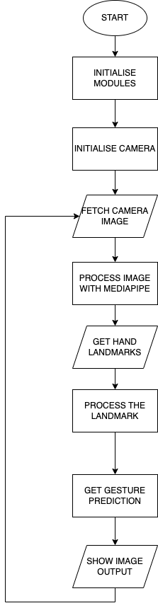

**MEDIAPIPE**

Since 2012, Google has been using Mediapipe internally in several products and services. It was initially developed for real-time analysis of video and audio on YouTube. Gradually it got integrated into many more products, such as

**Perception system in NestCam**

Object detection by Google Lens

Augmented Reality Ads

Google Photos

Google Home

Gmail

Cloud Vision API, etc.

MediaPipe powers revolutionary products and services we use daily. Unlike power-hungry machine learning Frameworks, MediaPipe requires minimal resources. It is so tiny and efficient that even embedded IoT devices can run it. In 2019, MediaPipe opened up a whole new world of opportunity for researchers and developers following its public release.

MediaPipe is a Framework for building machine learning pipelines for processing time-series data like video, audio, etc. This cross-platform Framework works in Desktop/Server, Android, iOS, and embedded devices like Raspberry Pi and Jetson Nano.

**Graphs**

The MediaPipe perception pipeline is called a **Graph**. Let us take the example of the first solution, Hands. We feed a stream of images as input which comes out with hand landmarks rendered on the images.



The flow chart below represents the MP (Abbr. MediaPipe) hand solution graph.



In computer science, a graph consists of Nodes connected by Edges. Inside the MediaPipe Graph, the nodes are called **Calculators**, and edges are called **Streams**. Every stream carries a sequence of **Packets**that have ascending time stamps.

In the image above, we have represented Calculators with rectangular blocks and Streams using arrows.

# **MediaPipe Hands**

The ability to perceive the shape and motion of hands can be a vital component in improving the user experience across a variety of technological domains and platforms. For example, it can form the basis for sign language understanding and hand gesture control, and can also enable the overlay of digital content and information on top of the physical world in augmented reality. While coming naturally to people, robust real-time hand perception is a decidedly challenging computer vision task, as hands often occlude themselves or each other (e.g. finger/palm occlusions and hand shakes) and lack high contrast patterns.

MediaPipe Hands is a high-fidelity hand and finger tracking solution. It employs machine learning (ML) to infer 21 3D landmarks of a hand from just a single frame. Whereas current state-of-the-art approaches rely primarily on powerful desktop environments for inference, our method achieves real-time performance on a mobile phone, and even scales to multiple hands. We hope that providing this hand perception functionality to the wider research and development community will result in an emergence of creative use cases, stimulating new applications and new research avenues.

## **ML Pipeline**

MediaPipe Hands utilizes an ML pipeline consisting of multiple models working together: A palm detection model that operates on the full image and returns an oriented hand bounding box. A hand landmark model that operates on the cropped image region defined by the palm detector and returns high-fidelity 3D hand keypoints. This strategy is similar to that employed in our MediaPipe Face Mesh solution, which uses a face detector together with a face landmark model.

Providing the accurately cropped hand image to the hand landmark model drastically reduces the need for data augmentation (e.g. rotations, translation and scale) and instead allows the network to dedicate most of its capacity towards coordinate prediction accuracy. In addition, in our pipeline the crops can also be generated based on the hand landmarks identified in the previous frame, and only when the landmark model could no longer identify hand presence is palm detection invoked to relocalize the hand.

The pipeline is implemented as a MediaPipe graph that uses a hand landmark tracking subgraph from the hand landmark module, and renders using a dedicated hand renderer subgraph. The hand landmark tracking subgraph internally uses a hand landmark subgraph from the same module and a palm detection subgraph from the palm detection module.

## **Models**

### **Palm Detection Model**

To detect initial hand locations, we designed a single-shot detector model optimized for mobile real-time uses in a manner similar to the face detection model in MediaPipe Face Mesh. Detecting hands is a decidedly complex task: our lite model and full model have to work across a variety of hand sizes with a large scale span (~20x) relative to the image frame and be able to detect occluded and self-occluded hands. Whereas faces have high contrast patterns, e.g., in the eye and mouth region, the lack of such features in hands makes it comparatively difficult to detect them reliably from their visual features alone. Instead, providing additional context, like arm, body, or person features, aids accurate hand localization.

Our method addresses the above challenges using different strategies. First, we train a palm detector instead of a hand detector, since estimating bounding boxes of rigid objects like palms and fists is significantly simpler than detecting hands with articulated fingers. In addition, as palms are smaller objects, the non-maximum suppression algorithm works well even for two-hand self-occlusion cases, like handshakes. Moreover, palms can be modelled using square bounding boxes (anchors in ML terminology) ignoring other aspect ratios, and therefore reducing the number of anchors by a factor of 3-5. Second, an encoder-decoder feature extractor is used for bigger scene context awareness even for small objects (similar to the RetinaNet approach). Lastly, we minimize the focal loss during training to support a large amount of anchors resulting from the high scale variance.

With the above techniques, we achieve an average precision of 95.7% in palm detection. Using a regular cross entropy loss and no decoder gives a baseline of just 86.22%.

### **Hand Landmark Model**

After the palm detection over the whole image our subsequent hand landmark model performs precise keypoint localization of 21 3D hand-knuckle coordinates inside the detected hand regions via regression, that is direct coordinate prediction. The model learns a consistent internal hand pose representation and is robust even to partially visible hands and self-occlusions.

To obtain ground truth data, we have manually annotated ~30K real-world images with 21 3D coordinates, as shown below (we take Z-value from image depth map, if it exists per corresponding coordinate). To better cover the possible hand poses and provide additional supervision on the nature of hand geometry, we also render a high-quality synthetic hand model over various backgrounds and map it to the corresponding 3D coordinates.

| **hand_landmarks.png** |
| --- |
| Fig 2. 21 hand landmarks. |
| **hand_crops.png** |
|  |
| Fig 3. Top: Aligned hand crops passed to the tracking network with ground truth annotation. Bottom: Rendered synthetic hand images with ground truth annotation. |

## **Solution APIs**

### **Configuration Options**

Naming style and availability may differ slightly across platforms/languages.

#### STATIC\_IMAGE\_MODE

If set to false, the solution treats the input images as a video stream. It will try to detect hands in the first input images, and upon a successful detection further localizes the hand landmarks. In subsequent images, once all [max\_num\_hands](https://google.github.io/mediapipe/solutions/hands.html" \l "max_num_hands) hands are detected and the corresponding hand landmarks are localized, it simply tracks those landmarks without invoking another detection until it loses track of any of the hands. This reduces latency and is ideal for processing video frames. If set to true, hand detection runs on every input image, ideal for processing a batch of static, possibly unrelated, images. Default to false.

#### MAX\_NUM\_HANDS

Maximum number of hands to detect. Default to 2.

#### MODEL\_COMPLEXITY

Complexity of the hand landmark model: 0 or 1. Landmark accuracy as well as inference latency generally go up with the model complexity. Default to 1.

#### MIN\_DETECTION\_CONFIDENCE

Minimum confidence value ([0.0, 1.0]) from the hand detection model for the detection to be considered successful. Default to 0.5.

#### MIN\_TRACKING\_CONFIDENCE:

Minimum confidence value ([0.0, 1.0]) from the landmark-tracking model for the hand landmarks to be considered tracked successfully, or otherwise hand detection will be invoked automatically on the next input image. Setting it to a higher value can increase robustness of the solution, at the expense of a higher latency. Ignored if [static\_image\_mode](https://google.github.io/mediapipe/solutions/hands.html" \l "static_image_mode) is true, where hand detection simply runs on every image. Default to 0.5.

### **Output**

Naming style may differ slightly across platforms/languages.

#### MULTI\_HAND\_LANDMARKS

Collection of detected/tracked hands, where each hand is represented as a list of 21 hand landmarks and each landmark is composed of x, y and z. x and y are normalized to [0.0, 1.0] by the image width and height respectively. z represents the landmark depth with the depth at the wrist being the origin, and the smaller the value the closer the landmark is to the camera. The magnitude of z uses roughly the same scale as x.

#### MULTI\_HAND\_WORLD\_LANDMARKS

Collection of detected/tracked hands, where each hand is represented as a list of 21 hand landmarks in world coordinates. Each landmark is composed of x, y and z: real-world 3D coordinates in meters with the origin at the hand’s approximate geometric center.

#### MULTI\_HANDEDNESS

Collection of handedness of the detected/tracked hands (i.e. is it a left or right hand). Each hand is composed of label and score. label is a string of value either "Left" or "Right". score is the estimated probability of the predicted handedness and is always greater than or equal to 0.5 (and the opposite handedness has an estimated probability of 1 - score).

Note that handedness is determined assuming the input image is mirrored, i.e., taken with a front-facing/selfie camera with images flipped horizontally. If it is not the case, please swap the handedness output in the application.

**CNN**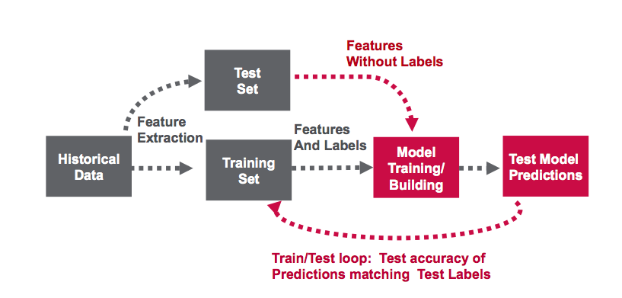



Convolutional neural network architecture

Algorithm:

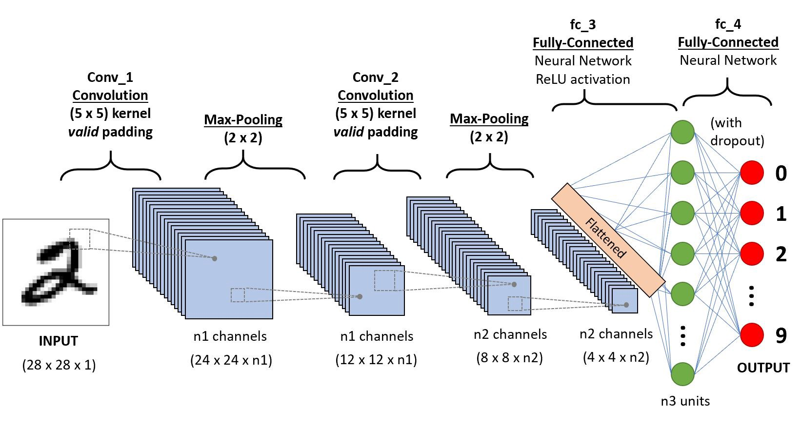

Example CNN sequence to classify handwritten digits

A **Convolutional Neural Network (ConvNet/CNN)** is a Deep Learning algorithm which can take in an input image, assign importance (learnable weights and biases) to various aspects/objects in the image and be able to differentiate one from the other. The pre-processing required in a ConvNet is much lower as compared to other classification algorithms. While in primitive methods filters are hand-engineered, with enough training, ConvNets have the ability to learn these filters/characteristics.

The architecture of a ConvNet is analogous to that of the connectivity pattern of Neurons in the Human Brain and was inspired by the organization of the Visual Cortex. Individual neurons respond to stimuli only in a restricted region of the visual field known as the Receptive Field. A collection of such fields overlaps to cover the entire visual area.

**Why ConvNets over Feed-Forward Neural Nets?**

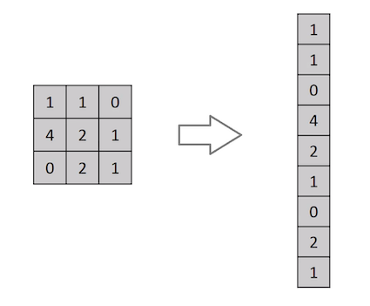

Flattening of a 3x3 image matrix into a 9x1 vector

An image is nothing but a matrix of pixel values, right? So why not just flatten the image (e.g. 3x3 image matrix into a 9x1 vector) and feed it to a Multi-Level Perceptron for classification purposes? Uh.. not really.

In cases of extremely basic binary images, the method might show an average precision score while performing prediction of classes but would have little to no accuracy when it comes to complex images having pixel dependencies throughout.

A ConvNet is able to **successfully capture the Spatial and Temporal dependencies** in an image through the application of relevant filters. The architecture performs a better fitting to the image dataset due to the reduction in the number of parameters involved and reusability of weights. In other words, the network can be trained to understand the sophistication of the image better.

**Input Image**

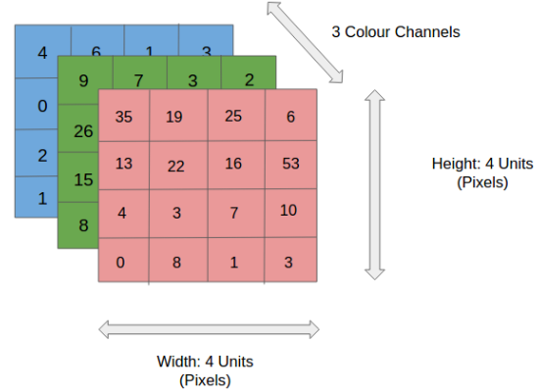

4x4x3 RGB Image

In the figure, we have an RGB image which has been separated by its three color planes — Red, Green, and Blue. There are a number of such color spaces in which images exist — Grayscale, RGB, HSV, CMYK, etc.

You can imagine how computationally intensive things would get once the images reach dimensions, say 8K (7680×4320). The role of the ConvNet is to reduce the images into a form which is easier to process, without losing features which are critical for getting a good prediction. This is important when we are to design an architecture which is not only good at learning features but also is scalable to massive datasets.

**Convolution Layer — The Kernel**



Convoluting a 5x5x1 image with a 3x3x1 kernel to get a 3x3x1 convolved feature

Image Dimensions = 5 (Height) x 5 (Breadth) x 1 (Number of channels, eg. RGB)

In the above demonstration, the green section resembles our **5x5x1 input image, I**. The element involved in carrying out the convolution operation in the first part of a Convolutional Layer is called the **Kernel/Filter, K**, represented in the color yellow. We have selected **K as a 3x3x1 matrix.**

Kernel/Filter, K = 1 0 1  
0 1 0  
1 0 1

The Kernel shifts 9 times because of **Stride Length = 1 (Non-Strided)**, every time performing a **matrix multiplication operation between K and the portion P of the image** over which the kernel is hovering.

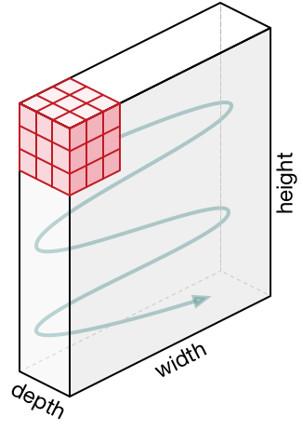

Movement of the Kernel

The filter moves to the right with a certain Stride Value till it parses the complete width. Moving on, it hops down to the beginning (left) of the image with the same Stride Value and repeats the process until the entire image is traversed.



Convolution operation on a MxNx3 image matrix with a 3x3x3 Kernel

In the case of images with multiple channels (e.g. RGB), the Kernel has the same depth as that of the input image. Matrix Multiplication is performed between Kn and In stack ([K1, I1]; [K2, I2]; [K3, I3]) and all the results are summed with the bias to give us a squashed one-depth channel Convoluted Feature Output.



Convolution Operation with Stride Length = 2

The objective of the Convolution Operation is to **extract the high-level features** such as edges, from the input image. ConvNets need not be limited to only one Convolutional Layer. Conventionally, the first ConvLayer is responsible for capturing the Low-Level features such as edges, color, gradient orientation, etc. With added layers, the architecture adapts to the High-Level features as well, giving us a network which has the wholesome understanding of images in the dataset, similar to how we would.

There are two types of results to the operation — one in which the convolved feature is reduced in dimensionality as compared to the input, and the other in which the dimensionality is either increased or remains the same. This is done by applying **Valid Padding** in case of the former, or **Same Padding** in the case of the latter.



**SAME padding:** 5x5x1 image is padded with 0s to create a 6x6x1 image

When we augment the 5x5x1 image into a 6x6x1 image and then apply the 3x3x1 kernel over it, we find that the convolved matrix turns out to be of dimensions 5x5x1. Hence the name — **Same Padding**.

On the other hand, if we perform the same operation without padding, we are presented with a matrix which has dimensions of the Kernel (3x3x1) itself — **Valid Padding**.

The following repository houses many such GIFs which would help you get a better understanding of how Padding and Stride Length work together to achieve results relevant to our needs.

**Pooling Layer**



3x3 pooling over 5x5 convolved feature

Similar to the Convolutional Layer, the Pooling layer is responsible for reducing the spatial size of the Convolved Feature. This is to **decrease the computational power required to process the data** through dimensionality reduction. Furthermore, it is useful for **extracting dominant features** which are rotational and positional invariant, thus maintaining the process of effectively training of the model.

There are two types of Pooling: Max Pooling and Average Pooling. **Max Pooling** returns the **maximum value** from the portion of the image covered by the Kernel. On the other hand, **Average Pooling**returns the **average of all the values**from the portion of the image covered by the Kernel.

Max Pooling also performs as a**Noise Suppressant**. It discards the noisy activations altogether and also performs de-noising along with dimensionality reduction. On the other hand, Average Pooling simply performs dimensionality reduction as a noise suppressing mechanism. Hence, we can say that **Max Pooling performs a lot better than Average Pooling**.

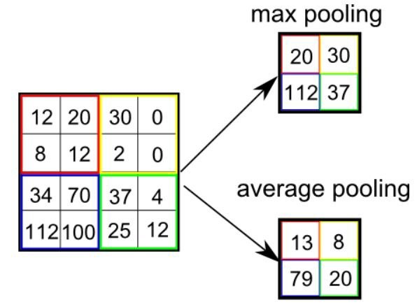

Types of Pooling

The Convolutional Layer and the Pooling Layer, together form the i-th layer of a Convolutional Neural Network. Depending on the complexities in the images, the number of such layers may be increased for capturing low-levels details even further, but at the cost of more computational power.

After going through the above process, we have successfully enabled the model to understand the features. Moving on, we are going to flatten the final output and feed it to a regular Neural Network for classification purposes.

**Classification — Fully Connected Layer (FC Layer)**

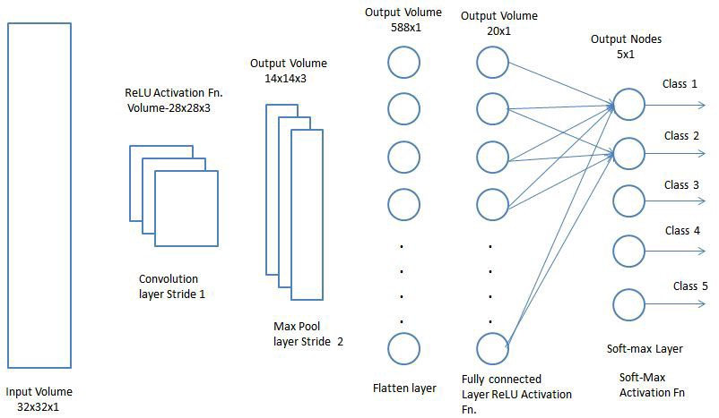

Adding a Fully-Connected layer is a (usually) cheap way of learning non-linear combinations of the high-level features as represented by the output of the convolutional layer. The Fully-Connected layer is learning a possibly non-linear function in that space.

Now that we have converted our input image into a suitable form for our Multi-Level Perceptron, we shall flatten the image into a column vector. The flattened output is fed to a feed-forward neural network and backpropagation applied to every iteration of training. Over a series of epochs, the model can distinguish between dominating and certain low-level features in images and classify them using the **Softmax Classification** technique.

# **Python**

Python is an interpreted, high-level, general-purpose programming language. Created by Guido van Rossum and first released in 1991, Python has a design philosophy that emphasizes code readability, notably using significant whitespace. It provides constructs that enable clear programming on both small and large scales. Van Rossum led the language community until stepping down as leader in July 2018.Python features a dynamic type system and automatic memory management. It supports multiple programming paradigms, including object-oriented, imperative, functional and procedural. It also has a comprehensive standard library. The Python interpreter and the extensive standard library are freely available in source or binary form for all major platforms from the Python Web site, https://www.python.org/, and may be freely distributed. The same site also contains distributions of and pointers to many free third party Python modules, programs and tools, and additional documentation.



Python is simple to use, but it is a real programming language, offering much more structure and support for large programs than shell scripts or batch files can offer. On the other hand, Python also offers much more error checking than C, and, being a very-high-level language, it has high-level data types built in, such as flexible arrays and dictionaries. Because of its more general data types Python is applicable to a much larger problem domain than Awk or even Perl, yet many things are at least as easy in Python as in those languages.

Python allows you to split your program into modules that can be reused in other Python programs. It comes with a large collection of standard modules that you can use as the basis of your programs — or as examples to start learning to program in Python. Some of these modules provide things like file I/O, system calls, sockets, and even interfaces to graphical user interface toolkits like Tk.

Python is an interpreted language, which can save you considerable time during program development because no compilation and linking is necessary. The interpreter can be used interactively, which makes it easy to experiment with features of the language, to write throw-away programs, or to test functions during bottom-up program development. It is also a handy desk calculator.

Python enables programs to be written compactly and readably. Programs written in Python are typically much shorter than equivalent C, C++, or Java programs, for several reasons:

* the high-level data types allow you to express complex operations in a single statement;
* statement grouping is done by indentation instead of beginning and ending brackets;
* no variable or argument declarations are necessary.

Python is extensible: if you know how to program in C it is easy to add a new built-in function or module to the interpreter, either to perform critical operations at maximum speed, or to link Python programs to libraries that may only be available in binary form (such as a vendor-specific graphics library). Once you are really hooked, you can link the Python interpreter into an application written in C and use it as an extension or command language for that application.

Invoking the Interpreter

The Python interpreter is usually installed as /usr/local/bin/python3.7 on those machines where it is available; putting /usr/local/bin in your Unix shell’s search path makes it possible to start it by typing the command:

python3.7

to the shell. [[1]](https://docs.python.org/3.7/tutorial/interpreter.html#id2) Since the choice of the directory where the interpreter lives is an installation option, other places are possible; check with your local Python guru or system administrator. (E.g., /usr/local/python is a popular alternative location.)

On Windows machines, the Python installation is usually placed in C:\Python37, though you can change this when you’re running the installer. To add this directory to your path, you can type the following command into the command prompt in a DOS box:

set path=%path%;C:\python37

Typing an end-of-file character (Control-D on Unix, Control-Z on Windows) at the primary prompt causes the interpreter to exit with a zero exit status. If that doesn’t work, you can exit the interpreter by typing the following command: quit().

The interpreter’s line-editing features include interactive editing, history substitution and code completion on systems that support readline. Perhaps the quickest check to see whether command line editing is supported is typing Control-P to the first Python prompt you get. If it beeps, you have command line editing; see Appendix Interactive Input Editing and History Substitution for an introduction to the keys. If nothing appears to happen, or if ^P is echoed, command line editing isn’t available; you’ll only be able to use backspace to remove characters from the current line.

The interpreter operates somewhat like the Unix shell: when called with standard input connected to a tty device, it reads and executes commands interactively; when called with a file name argument or with a file as standard input, it reads and executes a script from that file.

A second way of starting the interpreter is python -c command [arg] ..., which executes the statement(s) in command, analogous to the shell’s [-c](https://docs.python.org/3.7/using/cmdline.html#cmdoption-c) option. Since Python statements often contain spaces or other characters that are special to the shell, it is usually advised to quote command in its entirety with single quotes.

Some Python modules are also useful as scripts. These can be invoked using python -m module [arg] ..., which executes the source file for module as if you had spelled out its full name on the command line.

When a script file is used, it is sometimes useful to be able to run the script and enter interactive mode afterwards. This can be done by passing [-i](https://docs.python.org/3.7/using/cmdline.html#cmdoption-i) before the script.

**Argument Passing**

When known to the interpreter, the script name and additional arguments thereafter are turned into a list of strings and assigned to the argv variable in the sys module. You can access this list by executing import sys. The length of the list is at least one; when no script and no arguments are given, sys.argv[0] is an empty string. When the script name is given as '-' (meaning standard input), sys.argv[0] is set to '-'. When [-c](https://docs.python.org/3.7/using/cmdline.html#cmdoption-c)command is used, sys.argv[0] is set to '-c'. When [-m](https://docs.python.org/3.7/using/cmdline.html#cmdoption-m) module is used, sys.argv[0] is set to the full name of the located module. Options found after [-c](https://docs.python.org/3.7/using/cmdline.html#cmdoption-c) command or [-m](https://docs.python.org/3.7/using/cmdline.html#cmdoption-m) module are not consumed by the Python interpreter’s option processing but left in sys.argv for the command or module to handle.

**Interactive Mode**

When commands are read from a tty, the interpreter is said to be in interactive mode. In this mode it prompts for the next command with the primary prompt, usually three greater-than signs (>>>); for continuation lines it prompts with the secondary prompt, by default three dots (...). The interpreter prints a welcome message stating its version number and a copyright notice before printing the first prompt:

$ python3.7

Python 3.7 (default, Sep 16 2015, 09:25:04)

[GCC 4.8.2] on linux

Type "help", "copyright", "credits" or "license" for more information.

>>>

Continuation lines are needed when entering a multi-line construct. As an example, take a look at this [if](https://docs.python.org/3.7/reference/compound_stmts.html#if) statement:

>>>

>>> the\_world\_is\_flat = True

>>> if the\_world\_is\_flat:

... print("Be careful not to fall off!")

...

Be careful not to fall off!

In the following examples, input and output are distinguished by the presence or absence of prompts ([>>>](https://docs.python.org/3.7/glossary.html#term) and […](https://docs.python.org/3.7/glossary.html#term-1)): to repeat the example, you must type everything after the prompt, when the prompt appears; lines that do not begin with a prompt are output from the interpreter. Note that a secondary prompt on a line by itself in an example means you must type a blank line; this is used to end a multi-line command.

Many of the examples in this manual, even those entered at the interactive prompt, include comments. Comments in Python start with the hash character, #, and extend to the end of the physical line. A comment may appear at the start of a line or following whitespace or code, but not within a string literal. A hash character within a string literal is just a hash character. Since comments are to clarify code and are not interpreted by Python, they may be omitted when typing in examples.

**Some examples:**

# this is the first comment

spam = 1 # and this is the second comment

# ... and now a third!

text = "# This is not a comment because it's inside quotes."

Python uses [duck typing](https://en.wikipedia.org/wiki/Duck_typing) and has typed objects but untyped variable names. Type constraints are not checked at [compile time](https://en.wikipedia.org/wiki/Compile_time); rather, operations on an object may fail, signifying that the given object is not of a suitable type. Despite being [dynamically typed](https://en.wikipedia.org/wiki/Type_system#Dynamic_type_checking_and_runtime_type_information), Python is [strongly typed](https://en.wikipedia.org/wiki/Strongly_typed_programming_language), forbidding operations that are not well-defined (for example, adding a number to a string) rather than silently attempting to make sense of them.

Python allows programmers to define their own types using [classes](https://en.wikipedia.org/wiki/Class_(computer_science)), which are most often used for [object-oriented programming](https://en.wikipedia.org/wiki/Object-oriented_programming). New [instances](https://en.wikipedia.org/wiki/Object_(computer_science)) of classes are constructed by calling the class (for example, SpamClass() or EggsClass()), and the classes are instances of the [metaclass](https://en.wikipedia.org/wiki/Metaclass" \o "Metaclass) type (itself an instance of itself), allowing [metaprogramming](https://en.wikipedia.org/wiki/Metaprogramming) and [reflection](https://en.wikipedia.org/wiki/Reflection_(computer_science)).

Before version 3.0, Python had two kinds of classes: old-style and new-style. The syntax of both styles is the same, the difference being whether the class object is inherited from, directly or indirectly (all new-style classes inherit from object and are instances of type). In versions of Python 2 from Python 2.2 onwards, both kinds of classes can be used. Old-style classes were eliminated in Python 3.0.

The long term plan is to support [gradual typing](https://en.wikipedia.org/wiki/Gradual_typing)[[77]](https://en.wikipedia.org/wiki/Python_(programming_language)#cite_note-77) and from Python 3.5, the syntax of the language allows specifying static types but they are not checked in the default implementation, CPython. An experimental optional static type checker named mypy supports compile-time type checking.

Python has the usual C language arithmetic operators (+, -, \*, /, %). It also has \*\* for exponentiation, e.g. 5\*\*3 == 125 and 9\*\*0.5 == 3.0, and a new matrix multiply @ operator is included in version 3.5.[[80]](https://en.wikipedia.org/wiki/Python_(programming_language)#cite_note-80) Additionally, it has a unary operator (~), which essentially inverts all the bits of its one argument. For integers, this means ~x=-x-1.[[81]](https://en.wikipedia.org/wiki/Python_(programming_language)#cite_note-81) Other operators include bitwise shift operators x << y, which shifts x to the left y places, the same as x\*(2\*\*y) , and x >> y, which shifts x to the right y places, the same as x//(2\*\*y) .[[82]](https://en.wikipedia.org/wiki/Python_(programming_language)#cite_note-82)

The behavior of division has changed significantly over time:[[83]](https://en.wikipedia.org/wiki/Python_(programming_language)#cite_note-pep0238-83)[[why?](https://en.wikipedia.org/wiki/Wikipedia:Please_clarify)]

* Python 2.1 and earlier use the C division behavior. The / operator is integer division if both operands are integers, and floating-point division otherwise. Integer division rounds towards 0, e.g. 7/3 == 2 and -7/3 == -2.
* Python 2.2 changes integer division to round towards negative infinity, e.g. 7/3 == 2 and -7/3 == -3. The floor division // operator is introduced. So 7//3 == 2, -7//3 == -3, 7.5//3 == 2.0 and -7.5//3 == -3.0. Adding from \_\_future\_\_ import division causes a module to use Python 3.0 rules for division (see next).
* Python 3.0 changes / to be always floating-point division. In Python terms, the pre-3.0 / is classic division, the version-3.0 / is real division, and // is floor division.

Rounding towards negative infinity, though different from most languages, adds consistency. For instance, it means that the equation (a + b)//b == a//b + 1 is always true. It also means that the equation b\*(a//b) + a%b == a is valid for both positive and negative values of a. However, maintaining the validity of this equation means that while the result of a%b is, as expected, in the [half-open interval](https://en.wikipedia.org/wiki/Half-open_interval) [0, b), where b is a positive integer, it has to lie in the interval (b, 0] when b is negative.

Python provides a round function for [rounding](https://en.wikipedia.org/wiki/Rounding) a float to the nearest integer. For [tie-breaking](https://en.wikipedia.org/wiki/Rounding#Tie-breaking), versions before 3 use round-away-from-zero: round(0.5) is 1.0, round(-0.5) is −1.0. Python 3 uses [round to even](https://en.wikipedia.org/wiki/Round_to_even): round(1.5) is 2, round(2.5) is 2.

Python allows boolean expressions with multiple equality relations in a manner that is consistent with general use in mathematics. For example, the expression a < b < c tests whether a is less than b and b is less than c. C-derived languages interpret this expression differently: in C, the expression would first evaluate a < b, resulting in 0 or 1, and that result would then be compared with c.

Python has extensive built-in support for [arbitrary precision arithmetic](https://en.wikipedia.org/wiki/Arbitrary_precision_arithmetic). Integers are transparently switched from the machine-supported maximum fixed-precision (usually 32 or 64 bits), belonging to the python type int, to arbitrary precision, belonging to the Python type long, where needed. The latter have an "L" suffix in their textual representation. (In Python 3, the distinction between the int and long types was eliminated; this behavior is now entirely contained by the int class.) The Decimal type/class in module decimal (since version 2.4) provides decimal floating point numbers to arbitrary precision and several rounding modes. The Fraction type in module fractions (since version 2.6) provides arbitrary precision for rational numbers.[https://en.wikipedia.org/wiki/Python\_(programming\_language)](https://en.wikipedia.org/wiki/Python_(programming_language)#cite_note-91)

Due to Python's extensive mathematics library, and the third-party library [NumPy](https://en.wikipedia.org/wiki/NumPy) that further extends the native capabilities, it is frequently used as a scientific scripting language to aid in problems such as numerical data processing and manipulation.

# **Opencv**



OpenCV (Open Source Computer Vision Library) is released under a BSD license and hence it’s free for both academic and commercial use. It has C++, Python and Java interfaces and supports Windows, Linux, Mac OS, iOS and Android. OpenCV was designed for computational efficiency and with a strong focus on real-time applications. Written in optimized C/C++, the library can take advantage of multi-core processing. Enabled with OpenCL, it can take advantage of the hardware acceleration of the underlying heterogeneous compute platform.

OpenCV (Open Source Computer Vision Library) is an open source computer vision and machine learning software library. OpenCV was built to provide a common infrastructure for computer vision applications and to accelerate the use of machine perception in the commercial products. Being a BSD-licensed product, OpenCV makes it easy for businesses to utilize and modify the code.

The library has more than 2500 optimized algorithms, which includes a comprehensive set of both classic and state-of-the-art computer vision and machine learning algorithms. These algorithms can be used to detect and recognize faces, identify objects, classify human actions in videos, track camera movements, track moving objects, extract 3D models of objects, produce 3D point clouds from stereo cameras, stitch images together to produce a high resolution image of an entire scene, find similar images from an image database, remove red eyes from images taken using flash, follow eye movements, recognize scenery and establish markers to overlay it with augmented reality, etc. OpenCV has more than 47 thousand people of user community and estimated number of downloads exceeding 14 million. The library is used extensively in companies, research groups and by governmental bodies.

Along with well-established companies like Google, Yahoo, Microsoft, Intel, IBM, Sony, Honda, Toyota that employ the library, there are many startups such as Applied Minds, VideoSurf, and Zeitera, that make extensive use of OpenCV. OpenCV’s deployed uses span the range from stitching streetview images together, detecting intrusions in surveillance video in Israel, monitoring mine equipment in China, helping robots navigate and pick up objects at Willow Garage, detection of swimming pool drowning accidents in Europe, running interactive art in Spain and New York, checking runways for debris in Turkey, inspecting labels on products in factories around the world on to rapid face detection in Japan.

It has C++, Python, Java and MATLAB interfaces and supports Windows, Linux, Android and Mac OS. OpenCV leans mostly towards real-time vision applications and takes advantage of MMX and SSE instructions when available. A full-featured CUDAand OpenCL interfaces are being actively developed right now. There are over 500 algorithms and about 10 times as many functions that compose or support those algorithms. OpenCV is written natively in C++ and has a templated interface that works seamlessly with STL containers.

OpenCV has a modular structure, which means that the package includes several shared or static libraries. The following modules are available:

* Core functionality (core) - a compact module defining basic data structures, including the dense multi-dimensional array Mat and basic functions used by all other modules.
* Image Processing (imgproc) - an image processing module that includes linear and non-linear image filtering, geometrical image transformations (resize, affine and perspective warping, generic table-based remapping), color space conversion, histograms, and so on.
* Video Analysis (video) - a video analysis module that includes motion estimation, background subtraction, and object tracking algorithms.
* Camera Calibration and 3D Reconstruction (calib3d) - basic multiple-view geometry algorithms, single and stereo camera calibration, object pose estimation, stereo correspondence algorithms, and elements of 3D reconstruction.
* 2D Features Framework (features2d) - salient feature detectors, descriptors, and descriptor matchers.
* Object Detection (objdetect) - detection of objects and instances of the predefined classes (for example, faces, eyes, mugs, people, cars, and so on).
* High-level GUI (highgui) - an easy-to-use interface to simple UI capabilities.
* Video I/O (videoio) - an easy-to-use interface to video capturing and video codecs.
* ... some other helper modules, such as FLANN and Google test wrappers, Python bindings, and others.

OpenCV was started at Intel in 1999 by **Gary Bradsky** and the first release came out in 2000. **Vadim Pisarevsky** joined Gary Bradsky to manage Intel’s Russian software OpenCV team. In 2005, OpenCV was used on Stanley, the vehicle who won 2005 DARPA Grand Challenge. Later its active development continued under the support of Willow Garage, with Gary Bradsky and Vadim Pisarevsky leading the project. Right now, OpenCV supports a lot of algorithms related to Computer Vision and Machine Learning and it is expanding day-by-day.

Currently OpenCV supports a wide variety of programming languages like C++, Python, Java etc and is available on different platforms including Windows, Linux, OS X, Android, iOS etc. Also, interfaces based on CUDA and OpenCL are also under active development for high-speed GPU operations.

OpenCV-Python is the Python API of OpenCV. It combines the best qualities of OpenCV C++ API and Python language.

## **OpenCV-Python**

Python is a general purpose programming language started by **Guido van Rossum**, which became very popular in short time mainly because of its simplicity and code readability. It enables the programmer to express his ideas in fewer lines of code without reducing any readability.

Compared to other languages like C/C++, Python is slower. But another important feature of Python is that it can be easily extended with C/C++. This feature helps us to write computationally intensive codes in C/C++ and create a Python wrapper for it so that we can use these wrappers as Python modules. This gives us two advantages: first, our code is as fast as original C/C++ code (since it is the actual C++ code working in background) and second, it is very easy to code in Python. This is how OpenCV-Python works, it is a Python wrapper around original C++ implementation.

And the support of Numpy makes the task more easier. **Numpy** is a highly optimized library for numerical operations. It gives a MATLAB-style syntax. All the OpenCV array structures are converted to-and-from Numpy arrays. So whatever operations you can do in Numpy, you can combine it with OpenCV, which increases number of weapons in your arsenal. Besides that, several other libraries like SciPy, Matplotlib which supports Numpy can be used with this.

So OpenCV-Python is an appropriate tool for fast prototyping of computer vision problems

**Automatic Memory Management**

OpenCV handles all the memory automatically.

First of all, std::vector, cv::Mat, and other data structures used by the functions and methods have destructors that deallocate the underlying memory buffers when needed. This means that the destructors do not always deallocate the buffers as in case of Mat. They take into account possible data sharing. A destructor decrements the reference counter associated with the matrix data buffer. The buffer is deallocated if and only if the reference counter reaches zero, that is, when no other structures refer to the same buffer. Similarly, when a Mat instance is copied, no actual data is really copied. Instead, the reference counter is incremented to memorize that there is another owner of the same data. There is also the Mat::clone method that creates a full copy of the matrix data.

**Automatic Allocation of the Output Data**

OpenCV deallocates the memory automatically, as well as automatically allocates the memory for output function parameters most of the time. So, if a function has one or more input arrays (cv::Mat instances) and some output arrays, the output arrays are automatically allocated or reallocated. The size and type of the output arrays are determined from the size and type of input arrays. If needed, the functions take extra parameters that help to figure out the output array properties.

The array frame is automatically allocated by the >> operator since the video frame resolution and the bit-depth is known to the video capturing module. The array edges is automatically allocated by the cvtColor function. It has the same size and the bit-depth as the input array. The number of channels is 1 because the color conversion code cv::COLOR\_BGR2GRAY is passed, which means a color to grayscale conversion. Note that frame and edges are allocated only once during the first execution of the loop body since all the next video frames have the same resolution. If you somehow change the video resolution, the arrays are automatically reallocated.

The key component of this technology is the Mat::create method. It takes the desired array size and type. If the array already has the specified size and type, the method does nothing. Otherwise, it releases the previously allocated data, if any (this part involves decrementing the reference counter and comparing it with zero), and then allocates a new buffer of the required size. Most functions call the Mat::create method for each output array, and so the automatic output data allocation is implemented.

Some notable exceptions from this scheme are cv::mixChannels, cv::RNG::fill, and a few other functions and methods. They are not able to allocate the output array, so you have to do this in advance.

**Saturation Arithmetics**

As a computer vision library, OpenCV deals a lot with image pixels that are often encoded in a compact, 8- or 16-bit per channel, form and thus have a limited value range. Furthermore, certain operations on images, like color space conversions, brightness/contrast adjustments, sharpening, complex interpolation (bi-cubic, Lanczos) can produce values out of the available range. If you just store the lowest 8 (16) bits of the result, this results in visual artifacts and may affect a further image analysis. To solve this problem, the so-called saturation arithmetics is used. For example, to store r, the result of an operation, to an 8-bit image, you find the nearest value within the 0..255 range:

**I(x,y)=min(max(round(r),0),255)**

Similar rules are applied to 8-bit signed, 16-bit signed and unsigned types. This semantics is used everywhere in the library. In C++ code, it is done using the cv::saturate\_cast<> functions that resemble standard C++ cast operations.

**Fixed Pixel Types. Limited Use of Templates**

Templates is a great feature of C++ that enables implementation of very powerful, efficient and yet safe data structures and algorithms. However, the extensive use of templates may dramatically increase compilation time and code size. Besides, it is difficult to separate an interface and implementation when templates are used exclusively. This could be fine for basic algorithms but not good for computer vision libraries where a single algorithm may span thousands lines of code. Because of this and also to simplify development of bindings for other languages, like Python, Java, Matlab that do not have templates at all or have limited template capabilities, the current OpenCV implementation is based on polymorphism and runtime dispatching over templates. In those places where runtime dispatching would be too slow (like pixel access operators), impossible (generic cv::Ptr<> implementation), or just very inconvenient (cv::saturate\_cast<>()) the current implementation introduces small template classes, methods, and functions. Anywhere else in the current OpenCV version the use of templates is limited.

Consequently, there is a limited fixed set of primitive data types the library can operate on. That is, array elements should have one of the following types:

* 8-bit unsigned integer (uchar)
* 8-bit signed integer (schar)
* 16-bit unsigned integer (ushort)
* 16-bit signed integer (short)
* 32-bit signed integer (int)
* 32-bit floating-point number (float)
* 64-bit floating-point number (double)
* a tuple of several elements where all elements have the same type (one of the above). An array whose elements are such tuples, are called multi-channel arrays, as opposite to the single-channel arrays, whose elements are scalar values. The maximum possible number of channels is defined by the CV\_CN\_MAX constant, which is currently set to 512.

For these basic types, the following enumeration is applied:

**enum { CV\_8U=0, CV\_8S=1, CV\_16U=2, CV\_16S=3, CV\_32S=4, CV\_32F=5, CV\_64F=6 };**

Multi-channel (n-channel) types can be specified using the following options:

* CV\_8UC1 ... CV\_64FC4 constants (for a number of channels from 1 to 4)
* CV\_8UC(n) ... CV\_64FC(n) or CV\_MAKETYPE(CV\_8U, n) ... CV\_MAKETYPE(CV\_64F, n) macros when the number of channels is more than 4 or unknown at the compilation time.

Examples:

Mat mtx(3, 3, CV\_32F); // make a 3x3 floating-point matrix

Mat cmtx(10, 1, CV\_64FC2); // make a 10x1 2-channel floating-point

// matrix (10-element complex vector)

Mat img(Size(1920, 1080), CV\_8UC3); // make a 3-channel (color) image

// of 1920 columns and 1080 rows.

Mat grayscale(image.size(), CV\_MAKETYPE(image.depth(), 1)); // make a 1-channel image of

// the same size and same

// channel type as img

Arrays with more complex elements cannot be constructed or processed using OpenCV. Furthermore, each function or method can handle only a subset of all possible array types. Usually, the more complex the algorithm is, the smaller the supported subset of formats is. See below typical examples of such limitations:

* The face detection algorithm only works with 8-bit grayscale or color images.
* Linear algebra functions and most of the machine learning algorithms work with floating-point arrays only.
* Basic functions, such as cv::add, support all types.
* Color space conversion functions support 8-bit unsigned, 16-bit unsigned, and 32-bit floating-point types.

The subset of supported types for each function has been defined from practical needs and could be extended in future based on user requests.

### **InputArray and OutputArray**

Many OpenCV functions process dense 2-dimensional or multi-dimensional numerical arrays. Usually, such functions take cppMat as parameters, but in some cases it's more convenient to use std::vector<> (for a point set, for example) or cv::Matx<> (for 3x3 homography matrix and such). To avoid many duplicates in the API, special "proxy" classes have been introduced. The base "proxy" class is cv::InputArray. It is used for passing read-only arrays on a function input. The derived from InputArray class cv::OutputArray is used to specify an output array for a function. Normally, you should not care of those intermediate types (and you should not declare variables of those types explicitly) - it will all just work automatically. You can assume that instead of InputArray/OutputArray you can always use Mat, std::vector<>, cv::Matx<>, cv::Vec<> or cv::Scalar. When a function has an optional input or output array, and you do not have or do not want one, pass cv::noArray().

### **Error Handling**

OpenCV uses exceptions to signal critical errors. When the input data has a correct format and belongs to the specified value range, but the algorithm cannot succeed for some reason (for example, the optimization algorithm did not converge), it returns a special error code (typically, just a boolean variable).

The exceptions can be instances of the cv::Exception class or its derivatives. In its turn, cv::Exception is a derivative of std::exception. So it can be gracefully handled in the code using other standard C++ library components.

Multi-threading and Re-enterability

The current OpenCV implementation is fully re-enterable. That is, the same function or the same methods of different class instances can be called from different threads. Also, the same Mat can be used in different threads because the reference-counting operations use the architecture-specific atomic instructions.



Getting started with OpenCV's Python bindings is actually much easier than many people make it out to be initially. You will need two main libraries, with an optional third: python-OpenCV, Numpy, and Matplotlib.

### **Windows Users:**

[**python-OpenCV**](https://www.lfd.uci.edu/~gohlke/pythonlibs/#opencv) - There are alternative methods, but this is the easiest. Download the appropriate wheel (.whl) file, and install using pip. See video for help.

pip install numpy

pip install matplotlib

Not familiar with using pip? See the [**Pip installation tutorial**](https://pythonprogramming.net/using-pip-install-for-python-modules/) for help.

### **Linux / Mac Users:**

pip3 install numpy or apt-get install python3-numpy. You may need to apt-get install python3-pip.

pip3 install matplotlib or apt-get install python3-matplotlib.

apt-get install python3-OpenCV

[**Matplotlib**](https://pythonprogramming.net/matplotlib-intro-tutorial/) is an optional choice for displaying frames from video or images. We will show a couple of examples using it here. **[Numpy](https://www.numpy.org/" \t "blank)** is used for all things "numbers and Python." We are mainly making use of Numpy's array functionality. Finally, we are using the python-specific bindings for OpenCV called python-OpenCV.

There are some operations for OpenCV that you will not be able to do without a full installation of OpenCV (about 3GB in size), but you can actually do quite a bit with the fairly minimal installation of python-OpenCV. We will wind up using the full installation of OpenCV later in this series, so you can feel free to get it if you like, but these 3 modules will keep us busy for a while!

Make sure your installations were successful by running Python, and doing:

import cv2

import matplotlib

import numpy

If you get no errors, then you are ready to go. Ready? Let's dive off the deep-end!

First, we should understand a few basic assumptions and paradigms when it comes to image and video analysis. With the way just about every video camera records today, recordings are actually frames, displayed one after another, 30-60+ times a second. At the core, however, they are static frames, just like images. Thus, image recognition and video analysis use identical methods for the most part. Some things, like directional tracking, is going to require a succession of images (frames), but something like facial detection, or object recognition can be done with almost the exact same code on images and video.

Next, a lot of image and video analysis boils down to simplifying the source as much as possible. This almost always begins with a conversion to grayscale, but it can also be a color filter, gradient, or a combination of these. From here, we can do all sorts of analysis and transformations to the source. Generally, what winds up happening is there is a transformation done, then analysis, then any overlays that we wish to apply are applied back to the original source, which is why you can often see the "finished product" of maybe object or facial recognition being shown on a full-color image or video. Rarely is the data actually processed in raw form like this, however. Some examples of what we can do at a basic level. All of these are done with a basic web cam, nothing special:

#### Background Subtracting:

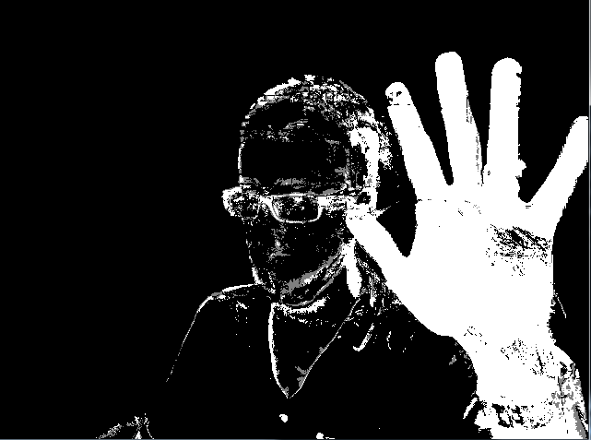

#### Color filtering:

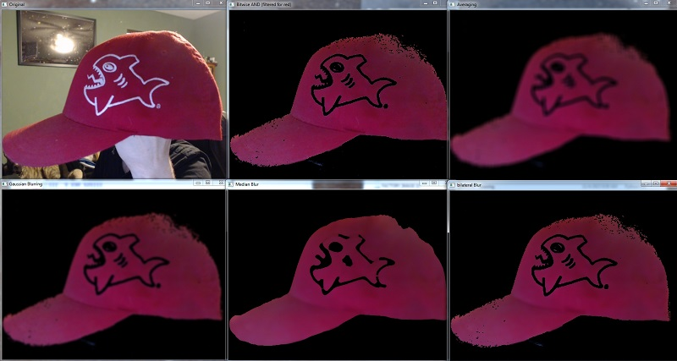

#### Edge detection:

